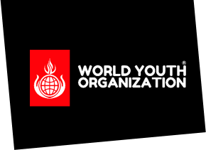

Pre-employment Checklist
World Youth Organization

Employee Details
Employee Name:
Role Applied For:
Volunteer/Trustee |  | ☐ | Payed Staff |  | ☐
Disclosure Barring Service (DBS)
Basic DBS Check |  | ☐ | Standard DBS Check |  | ☐
Enhanced DBS Check |  | ☐ | N/A |  | ☐
Reference
Former Employer (line manager) |  | ☐ | Teacher |  | ☐
Colleague |  | ☐ | Friend/Family |  | ☐
Right to Work Status
Right to Work |  | ☐ | N/A |  | ☐
Mandatory Training/Consent
Safer Staffing & Recruitment |  | ☐ | Equality and Diversity |  | ☐
LGBTQ+ Awareness |  | ☐ | Child Protection Awareness |  | ☐
Confidentiality/Info Sharing |  | ☐ | Designated Safeguarding Lead |  | ☐
WYO Educate Facilitator Training |  | ☐ | Mental Health First Aid Training |  | ☐
Video/Photography Consent |  | ☐ | Social Media Training |  | ☐
Signed off by appropriate member of staff
Name | Date |  |  | Role at Charity

